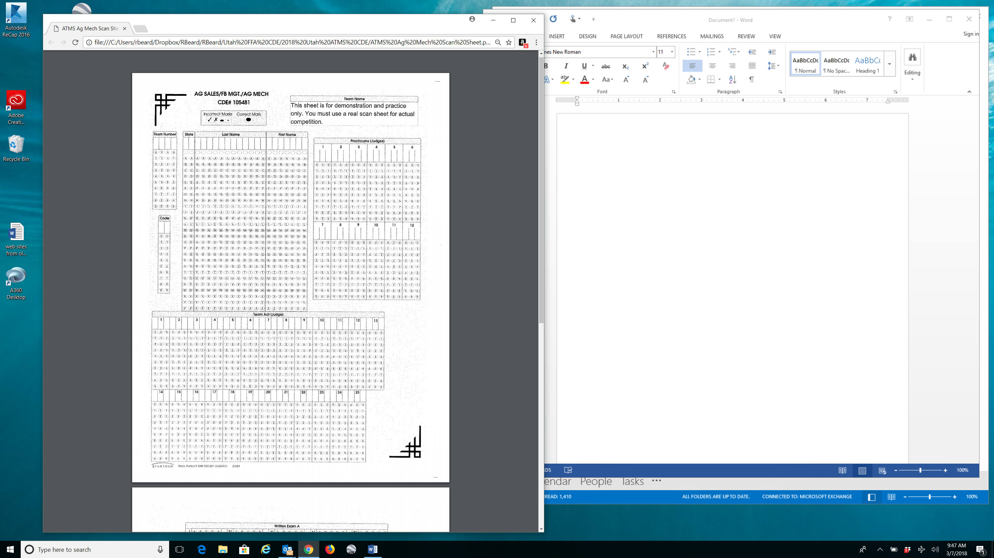

**Scan Sheet for**

Write name of your high school in this space.

Insert Student Number here. Values will be 01, 02, 03, or 04. Each student will be given one of these four number when they check in on the day of the CDE.

Insert Chapter ID number here. Values range from 0001 to 0103.

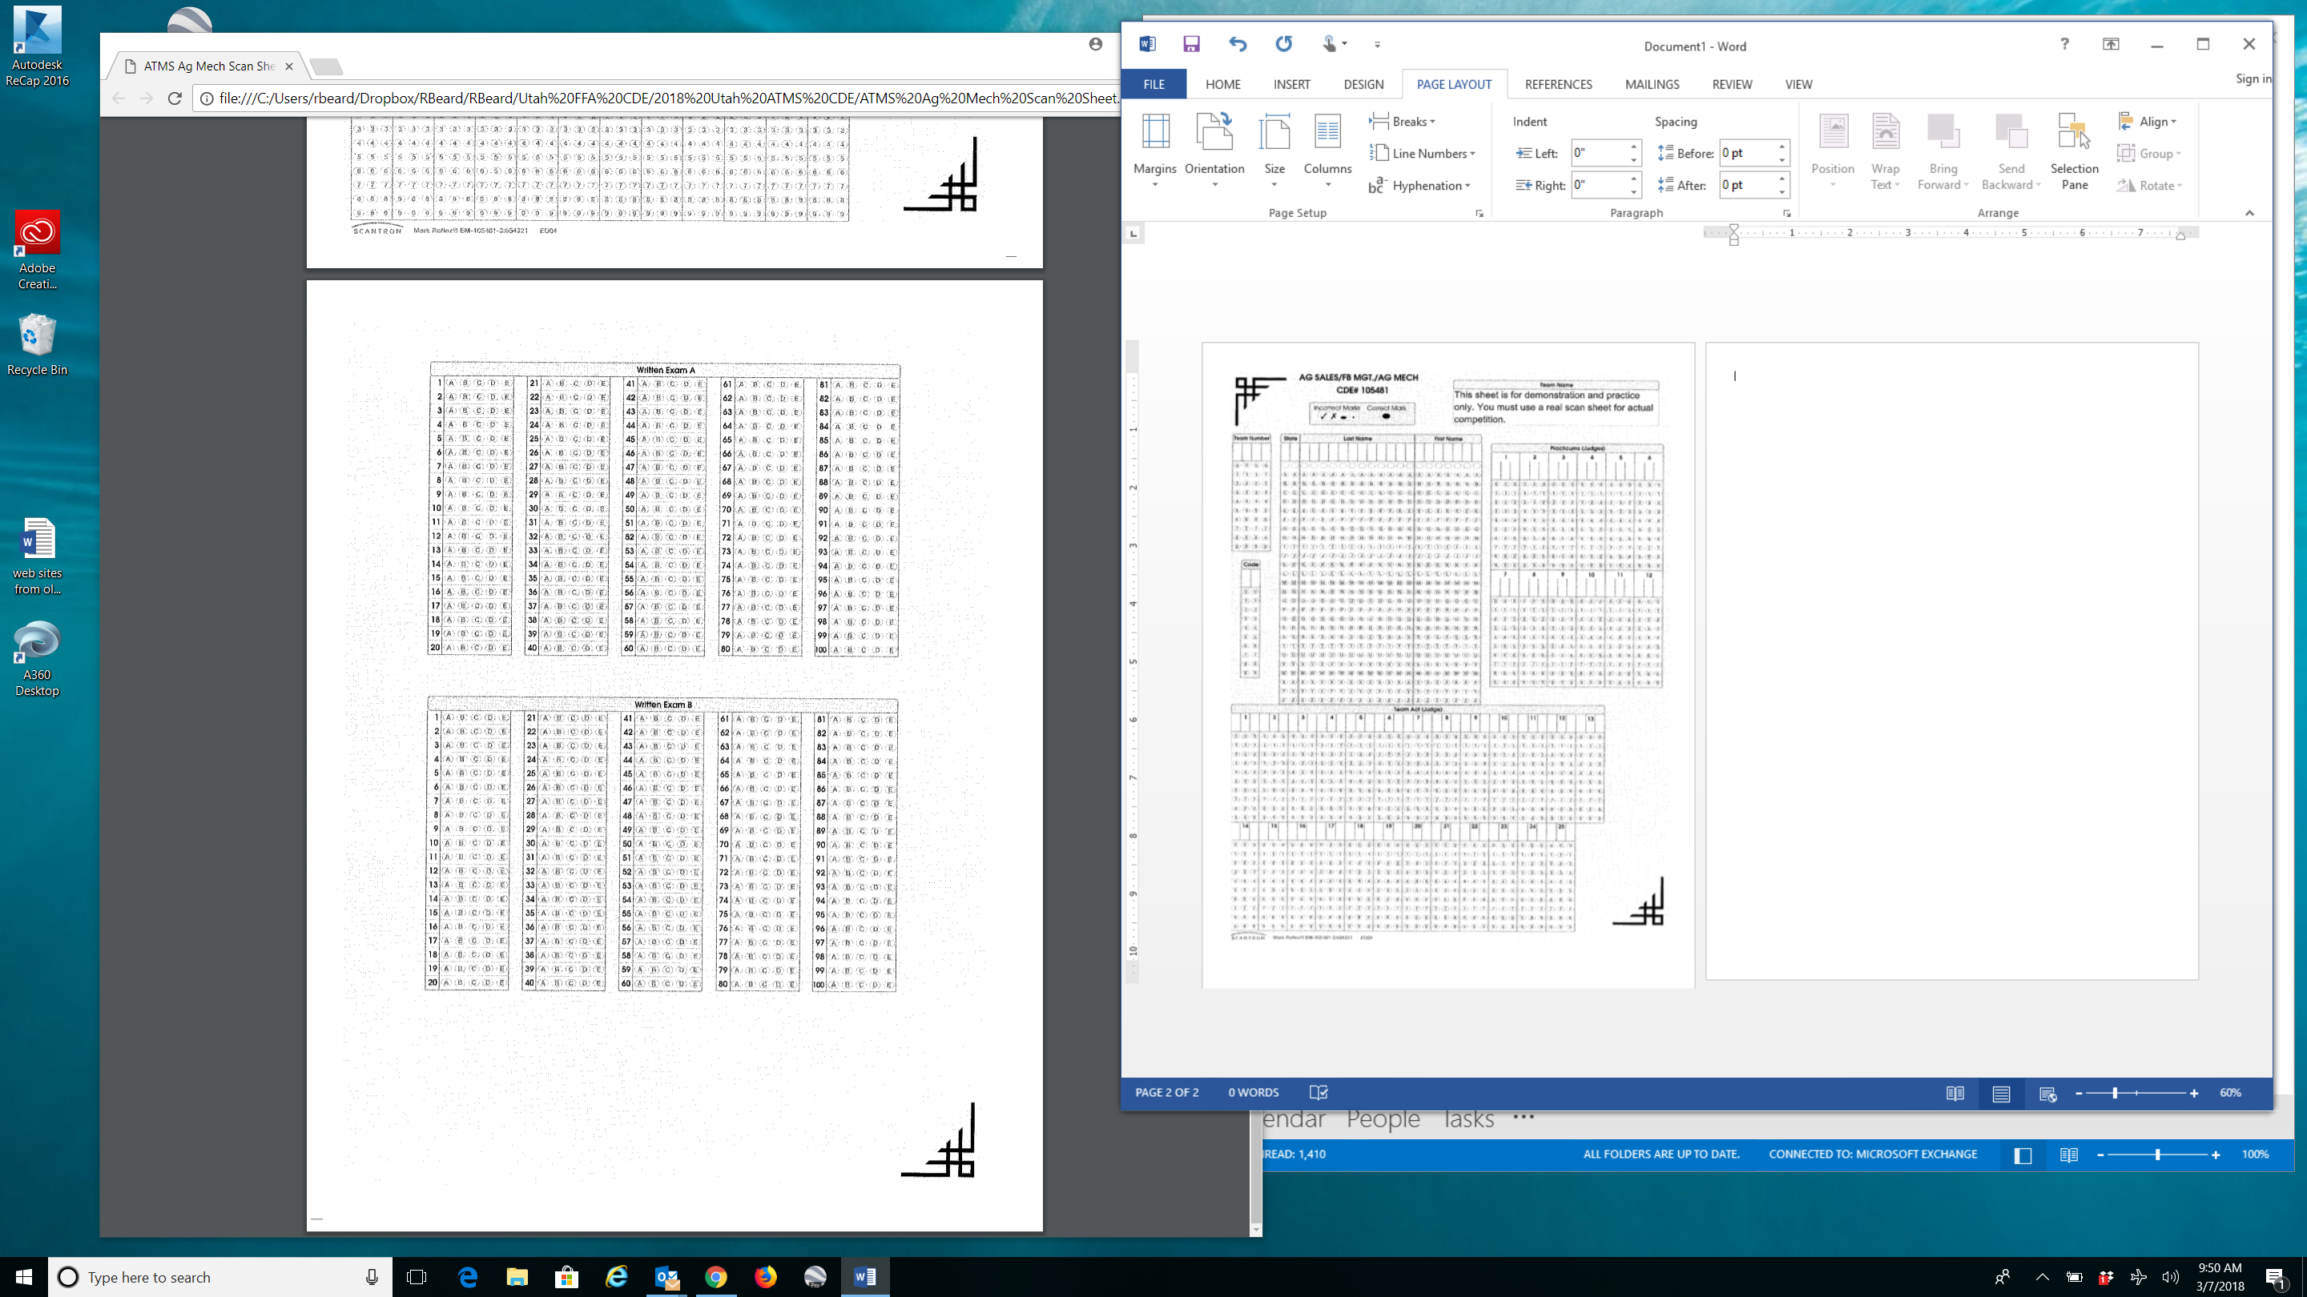

Place answers to the 25 Skill Questions in this section, numbers 1 through 50 (or more).

Place answers to the 25 (paper) Exam Questions in this section, numbers 1 through 25.